Exp 9
Fog Computing

Definition :
Fog computing refers to a decentralized computing structure, where resources, including the data and applications, get placed in logical locations between the data source and the cloud it also known by the terms ‘fogging’ and ‘fog networking.’
The goal of this is to bring basic analytic services to the network edge, improving performance by positioning computing resources closer to where they are needed, thereby reducing the distance that data needs to be transported on the network, improving overall network efficiency and performance.
Any device with computing, storage, and network connectivity can be a fog node. Examples include industrial controllers, switches, routers, embedded servers, and video surveillance cameras.
Fog computing can also be deployed for security reasons, as it has the ability to segment bandwidth traffic, and introduce additional firewalls to a network for higher security.
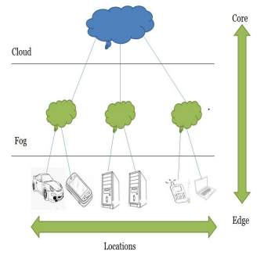
Characteristics :
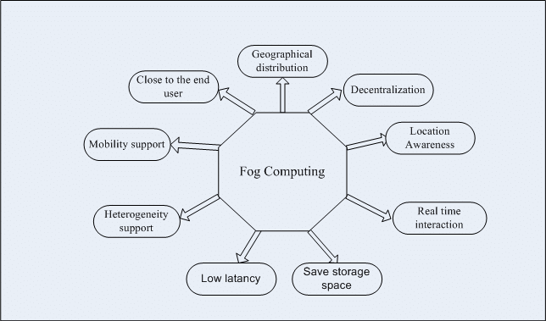

Services :
Communication service : The communication in the Internet-of-Things is dominated by wireless nodes. Due to the resource constraints in the perception layer, these wireless protocols are optimized for low power operation, narrow-band transmission or longer range of coverage.
Storage service : A huge amount of data can be generated by the sensor nodes and there are billions of these sensor devices around. The storage available in the devices at the perception layer is not often sufficient to store even a one-day data considering the rate of data generation.
Computing service : The limitations of computing power of the devices in the perception layer has led to the introduction of remote processing approaches. Processing at the Fog layer is not only motivated by the constraint of processing power at sensor nodes, but also by the desired location of computing to better meet system requirements and maintain energy efficiency.

Advantages :
- Better Security
- Lower Operational Costs
- Save Bandwidth Latency
- Better Privacy
- Easy To Develop Fog Applications
Disadvantages :
- More Difficult For Arbitrary Devices
- Security Issues
- More Efforts For Data Consistency
- Trust and authentication are major concerns
- Complex Scheduling

